**Decision Tree:**

Root Nodes: no arrows pointing outwards

Internal Nodes: arrows pointing inwards and outwards

Leaf Nodes: Arrows pointing outwards

**Pruning:** When we reduce the size of decision trees by removing nodes (opposite of Splitting), the process is called pruning.

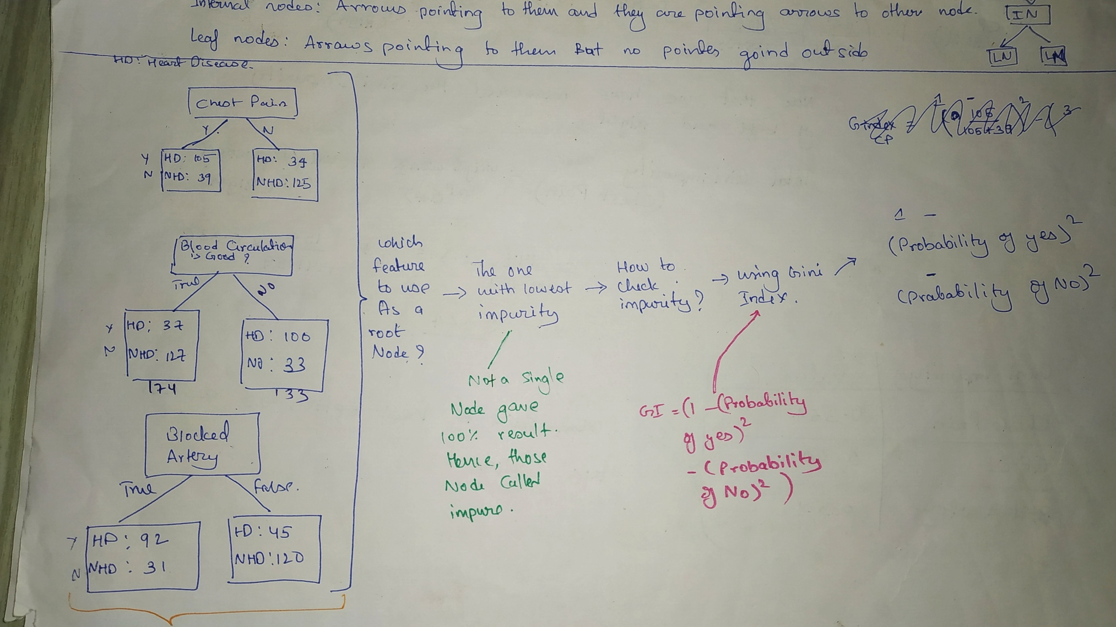

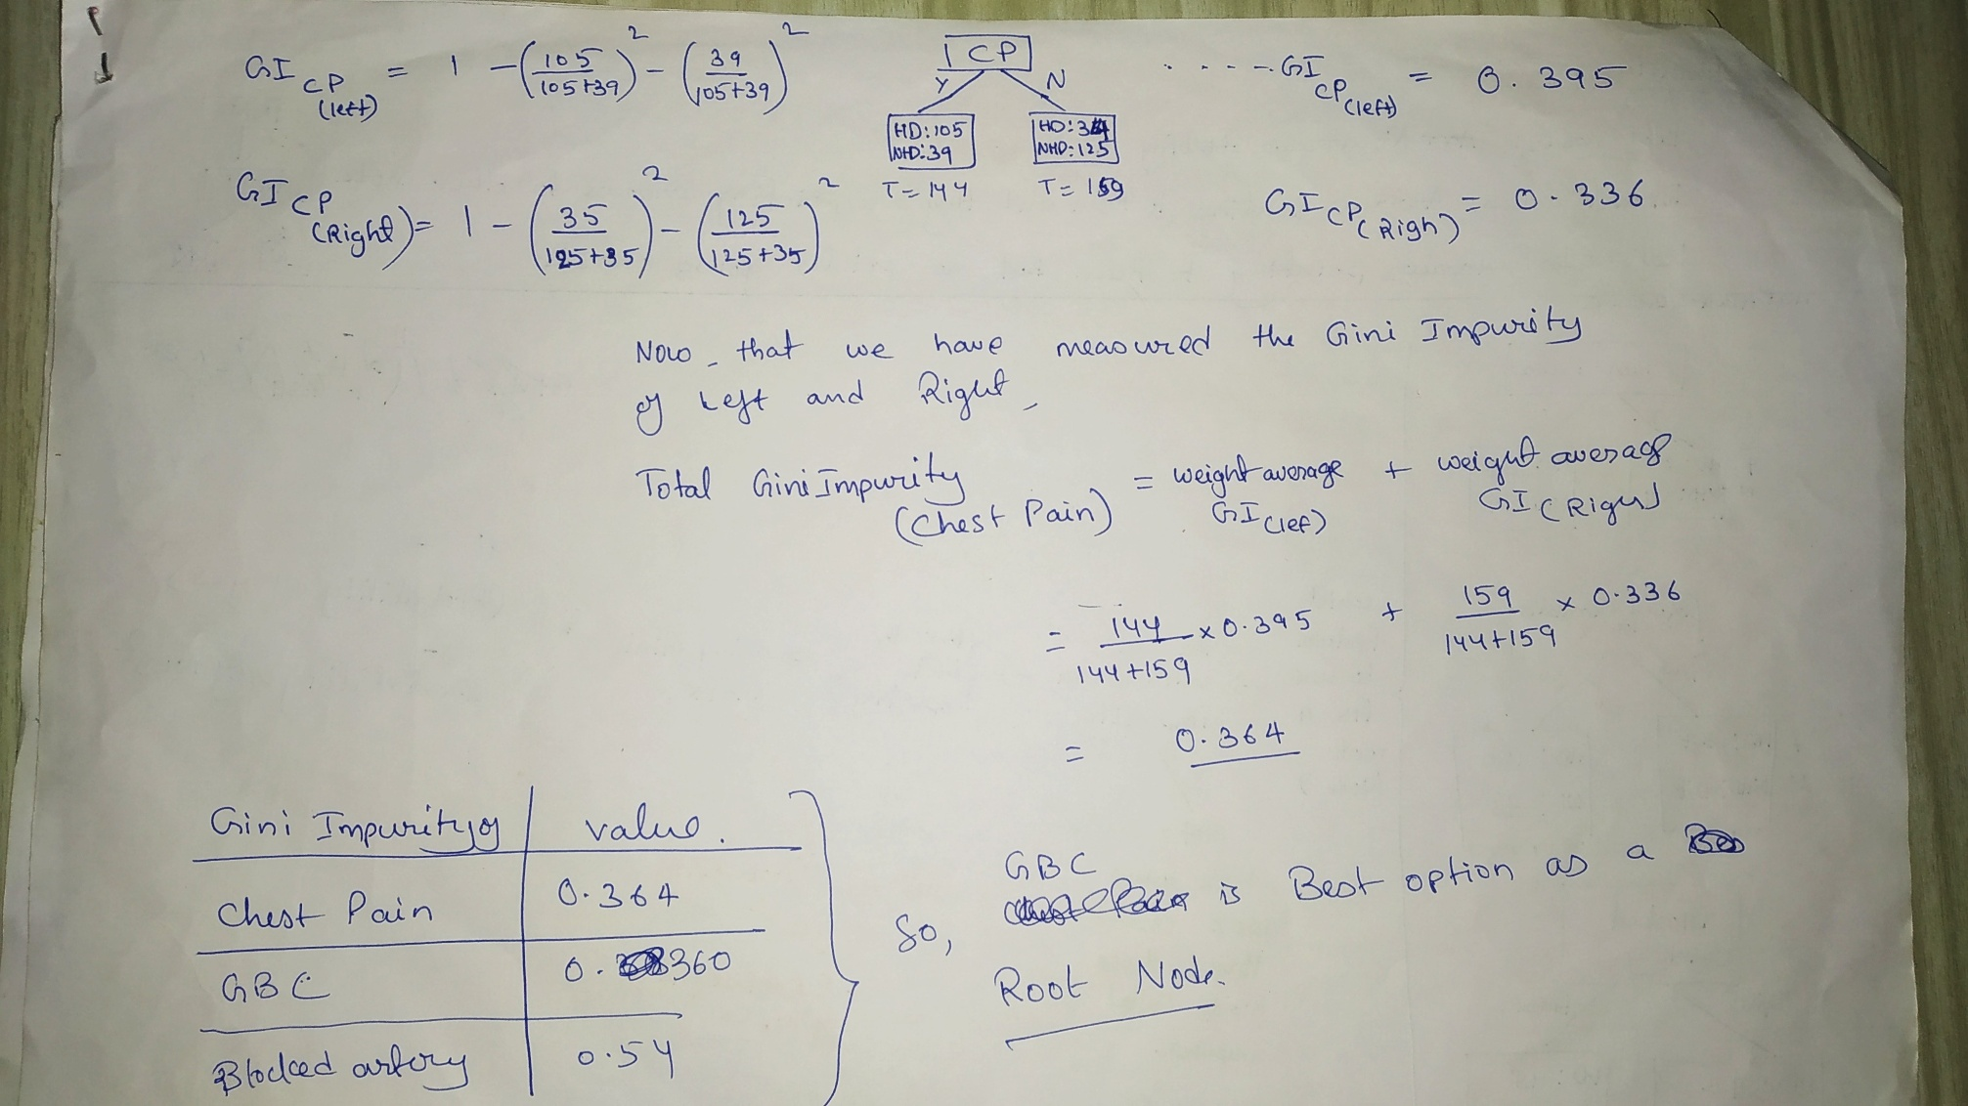

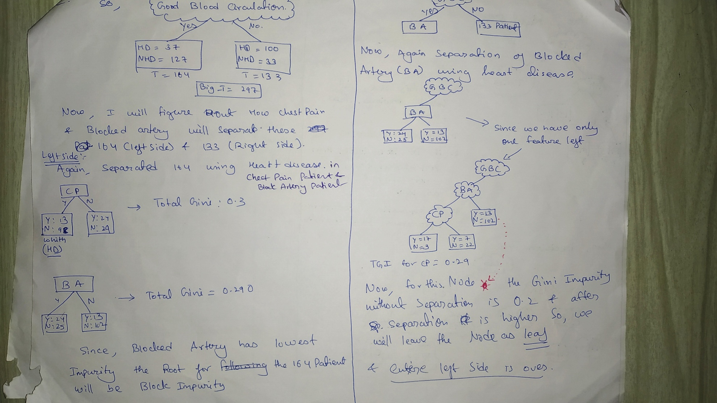

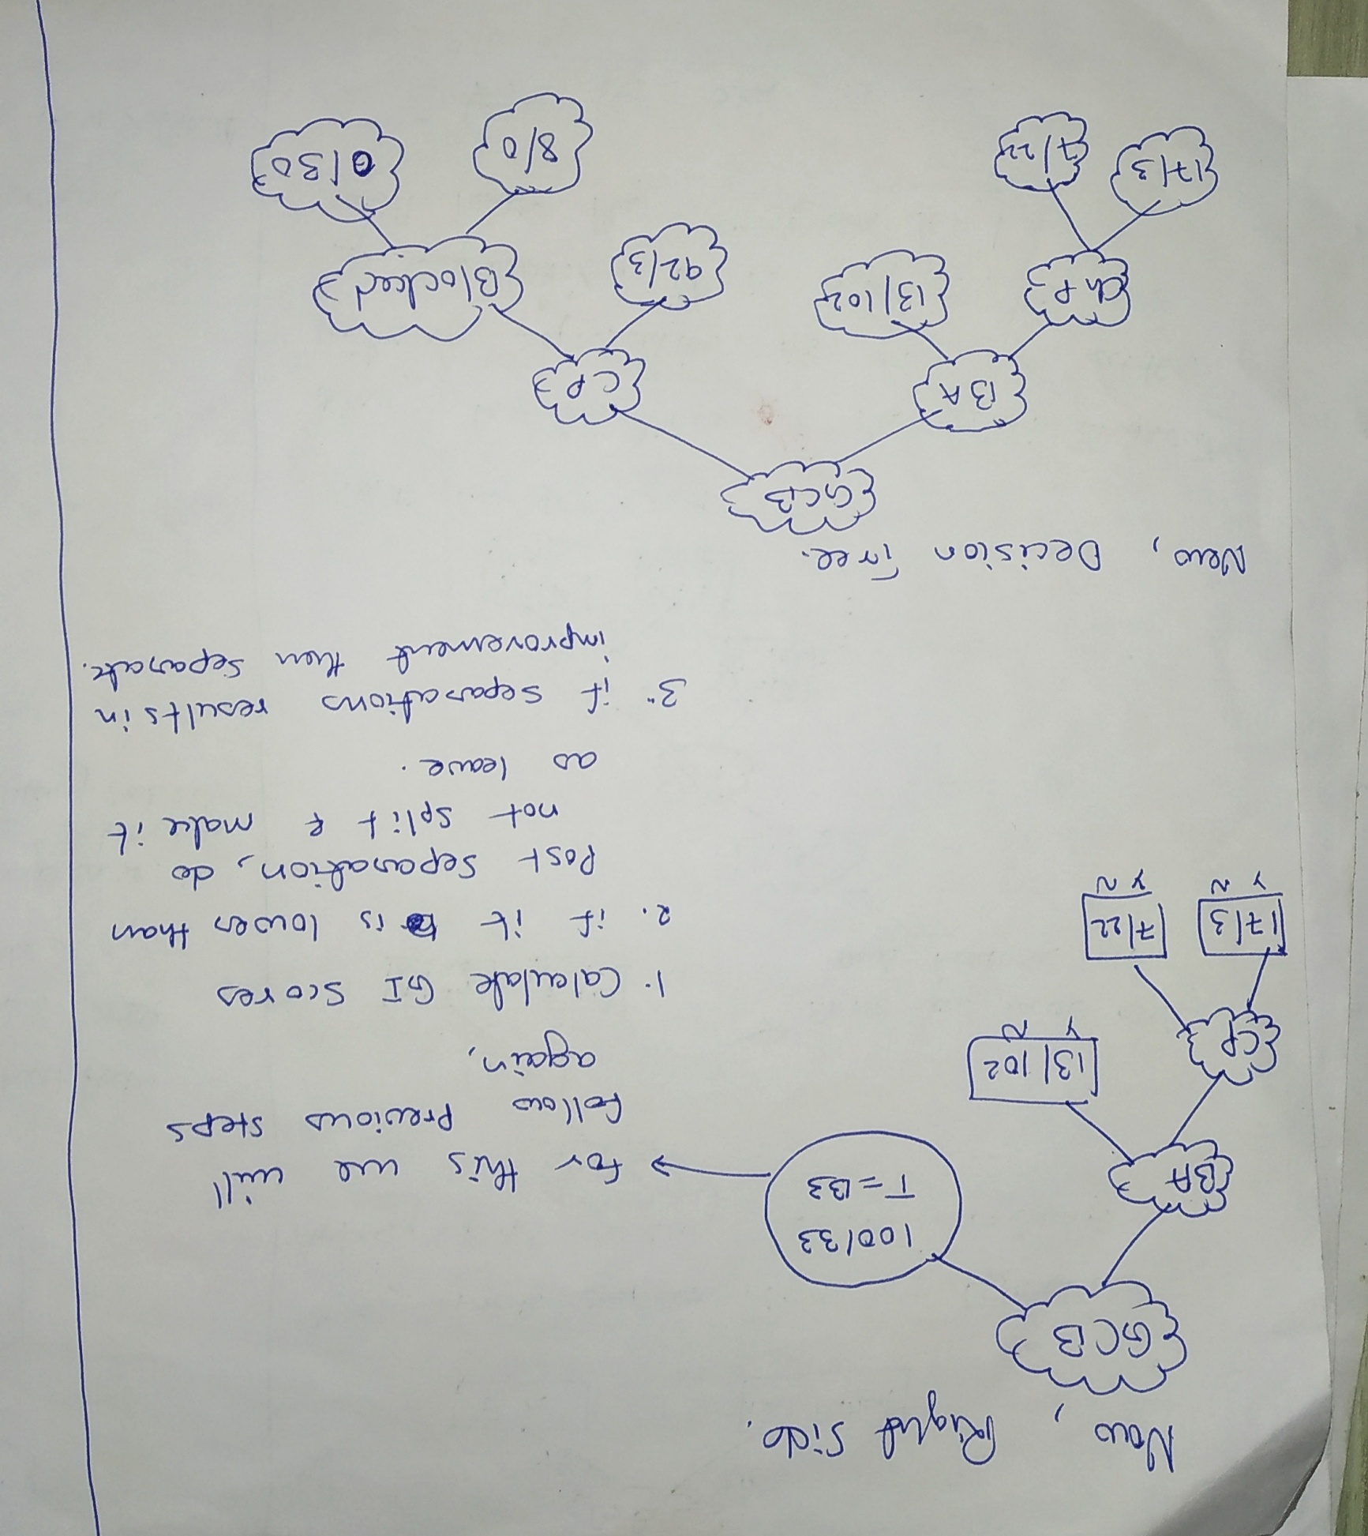

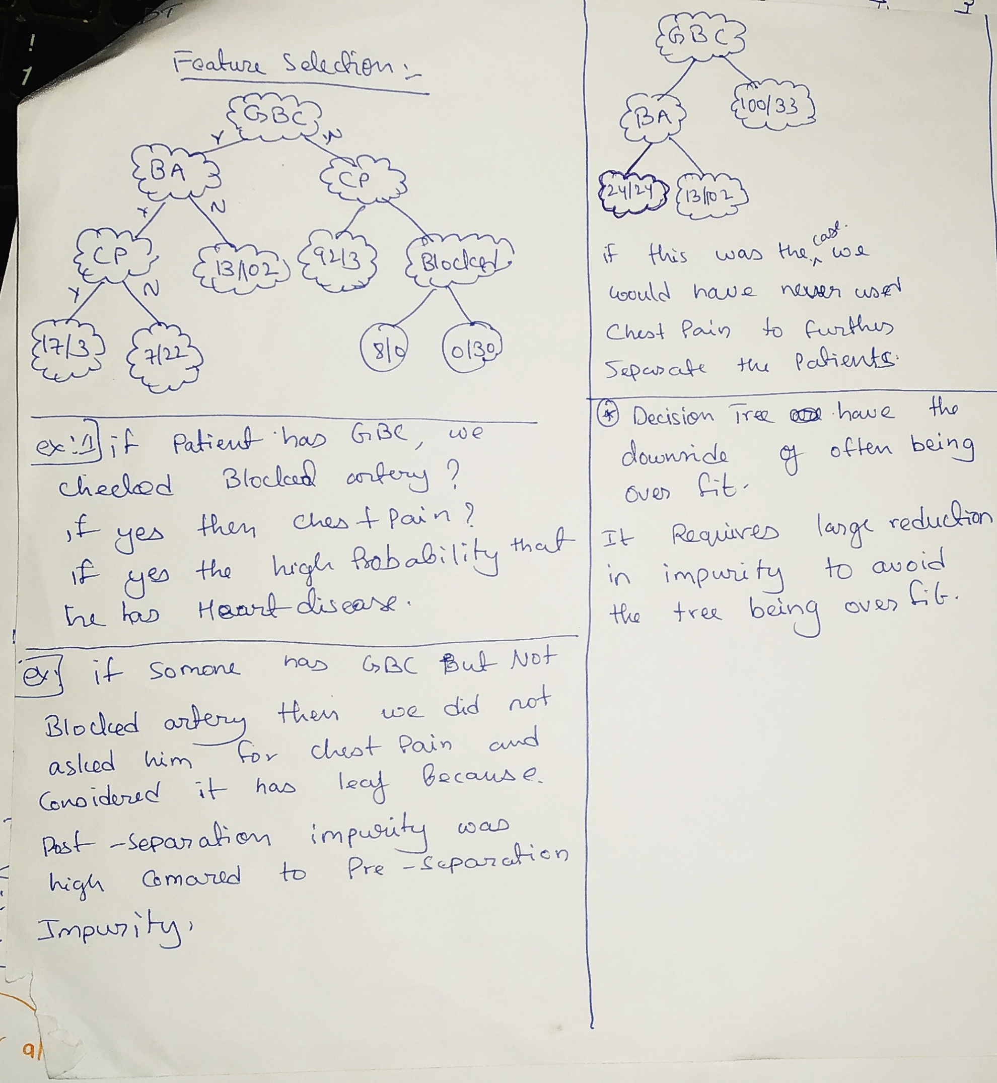

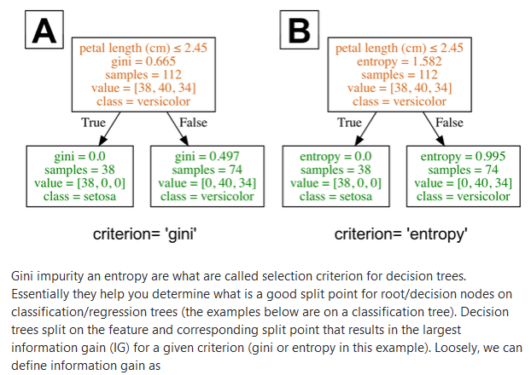

**Entropy: Entropy**, as it relates to machine learning, is a measure of the randomness in the information being processed. The higher the entropy, the harder it is to draw any conclusions from that information.

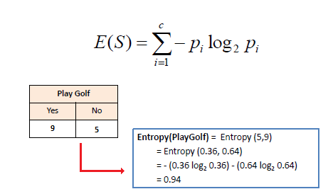

P(No)

P(yes)